Issue –

Backup failed on VM.

Microsoft video-

<https://youtu.be/thRp2ENpq1s?si=zIfWbDRI0H-SQlIv>

Those VMs are the part of Dev Test Lab-

Dev Test Lab VM service designed to help developers and testers quickly create and manage environments in Azure. Here are some key points about it:

DevTest Labs VMs are Azure VMs but with added features tailored for dev/test scenarios. These include auto-shutdown policies, cost management tools, artifact repositories for installing software, and the ability to claim VMs. These features help in managing costs and streamlining the development process.

* **Purpose**: DevTest Labs allows you to create, use, and manage infrastructure-as-a-service (IaaS) VMs for development, testing, and training scenarios
* **Customization**: You can use preconfigured bases, artifacts, and templates to create VMs. This includes custom images and formulas that can be tailored to specific needs
* **Cost Control**: The service includes features to control costs, such as setting policies for VM sizes and numbers, auto-shutdown schedules, and monitoring usage
* **Artifacts**: These are tools, actions, or software that can be added to VMs to customize them further. Artifacts can be selected from public repositories or private ones connected to the lab
* **Artifacts**: Predefined scripts/tools for installing software (e.g., Visual Studio, Docker) during VM provisioning.
* **Claimable VMs**: VMs can be "claimed" by users in a shared lab environment.

To create those Dev Test VM we must have Dev Test Lab environment created.  
  
Under the Dev Test Lab we can created vast numbers of resources such as Appservice webapp, VM, AKS and many more.

Create Dev test lab environment.

Go to azure market place and search for dev test lab.

Go for create option and provide required details.

Configure the auto shutdown feature for cost reduction.

Assign tags, configure networking and go for create.

Once the dev test lab creation is done will see the home page for it. Go to add for creating any resource.

We will see the numbers of resources available. Search and find by required resource.

Choose the resource type, suppose I am looking for a VM.

Provide required details such as vm name and other configuration data.

We can save the password or if e have any secret saved we can use that as password and use it for authentication.

Example for secret-

If don’t have any existing can create 1 and use.

Choose the disk size and disk type such as HDD, SSD or standard/premium.

Next option we will get artifact.  
  
Go for add or delete artifact. This is the place where we can add or delete any artifact application from azure dev test lab artifact git repository.

If we have any customized artifact we can add those as well.

Suppose we want node application to be installed on the server.

Those are coming from chocolatery package manager which we use to install applications from package by using PowerShell command.

If the required software have different versions we can choose that as well such as visual studio.

I am installing those 3 applications node, vs code and eclipse.

Define the required details such as vm expiratory number of vms we need etc..

Assign Tag and create.

This time we had create the vm which is non claimable. Let’s have another vm which is claimable.

Once the both resource created we can see the resources under the resource tab.

The claimable vm we can see under “claimable virtual machine section”

Go to VM and test all the applications are installed correctly.

If still in artifact applying state wait till completes.

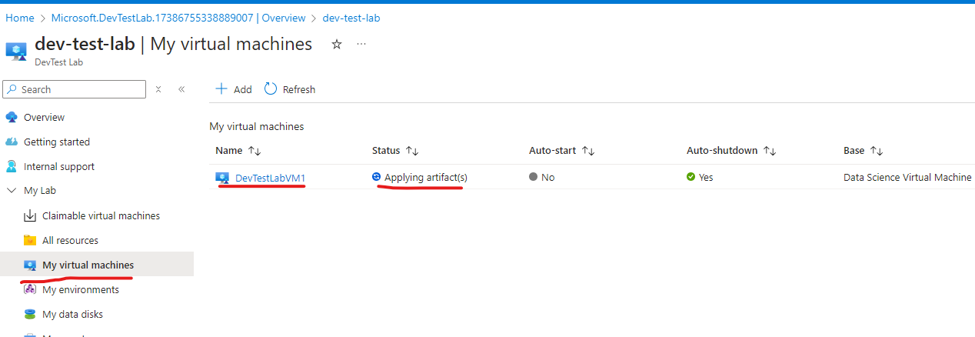

Note- here we don’t need to have automation account or tag assigned for auto start and stop, dev test lab provides that future.

The VM creation time depends on what all artifacts (software) we are installing.

Once the creation is doe start the vm.

Go for connect download RDP file and connect .

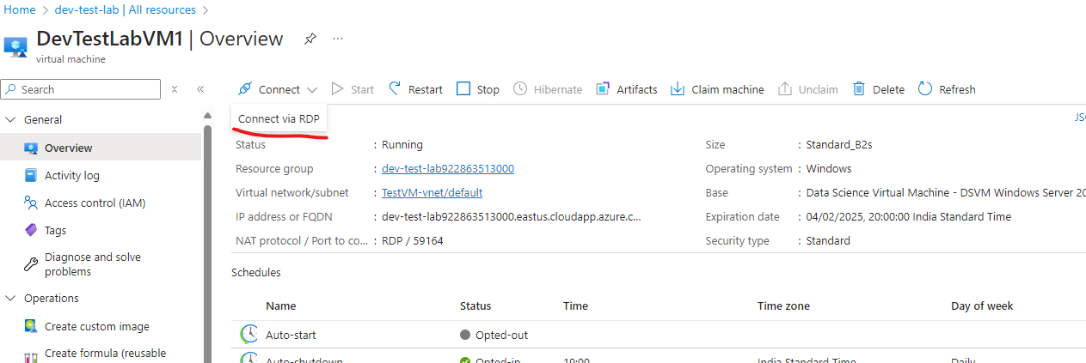

Post connection verified all applications installed successfully.

How to connect linux vm.

Go to VM connect option and choose connect via CLI or powershell.

If connecting via CLI we have 2 options either connect from azure or from local workstations.

If connecting via azure do configuration precheck and connect it will open the connection on cloudshell.

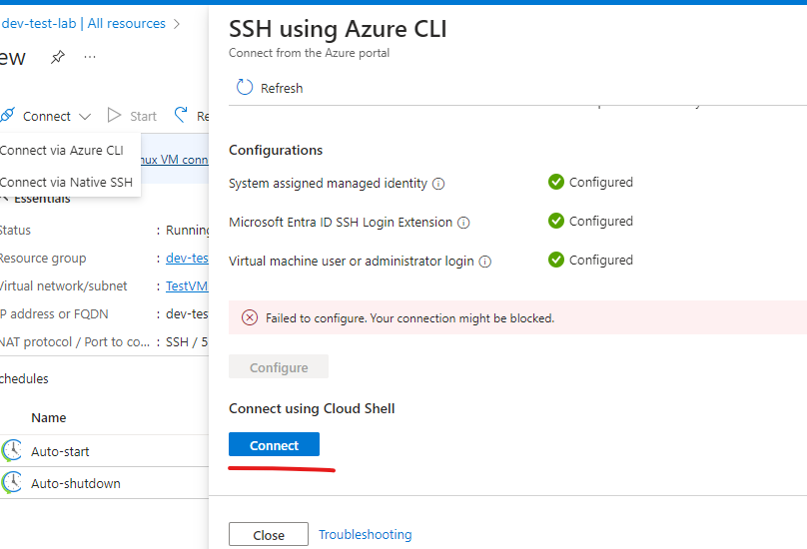

Connect via local machine cmd will be given we can use those commands to connect.

Or can take ssh connection as well.

Note- for each resource it will create a individual RG and keep all associated data.

Note- if the vm is not claimed we will see the option to claim it.

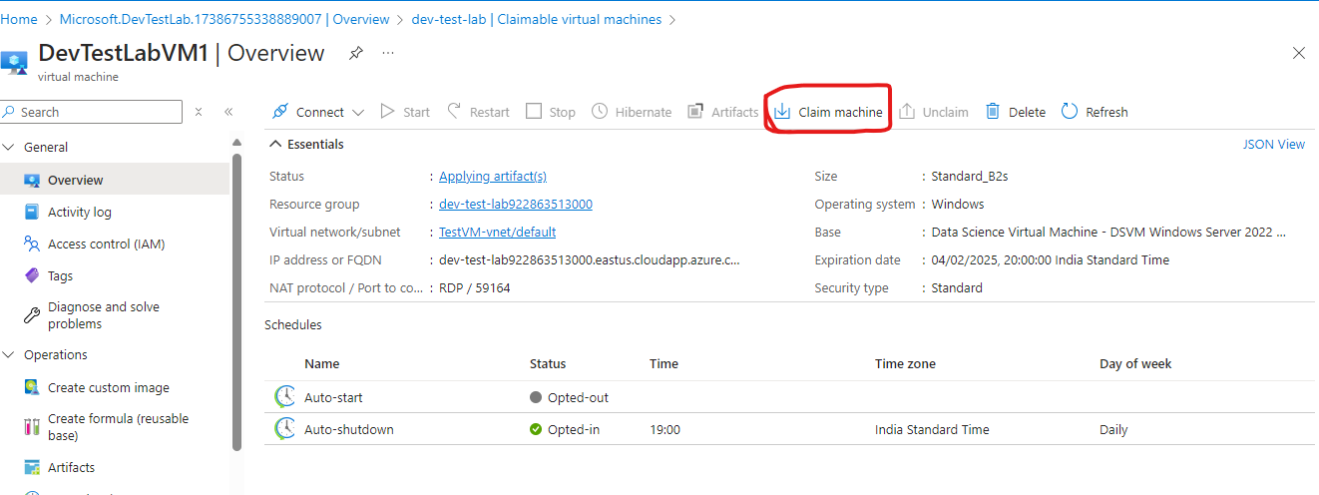

If the vm is claimed we will see the option to un-claim it.

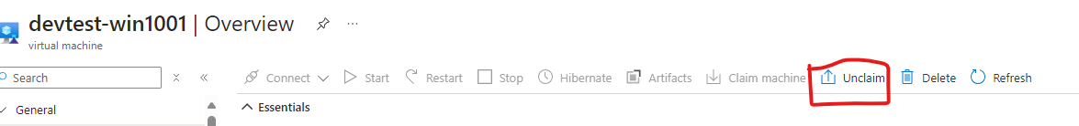

Once the vm is experied then we will not have any access to the vm and the vm will decom automatically.

Issue for Eriez client-

All the VM are not expired but status is corrupted.

Corrupted vm can not be redeployed.

In this case we must follow he activity log to track what is the exact reason for vm corruption.

If we have the backup on the vm we can restore. Either need to reach Microsoft support.

there are several common reasons why a virtual machine (VM) might become corrupted:

1. **Software Crashes**: The VM's operating system can crash due to software bugs, unstable updates, or incompatible drivers, leading to file system corruption
2. **Storage System Failures**: Issues with the storage system hosting the VM's virtual disk files, such as hardware failures or file corruption, can cause VM corruption
3. **Virtual Disk Corruption**: Errors within the VM's virtual disk files (e.g., VMDK, VHD) can occur due to disk errors within the guest OS or incorrect modifications
4. **Accidental Deletion**: Deleting or overwriting the VM's virtual disks or configuration files by mistake can lead to corruption
5. **Hypervisor Failures**: Problems with the hypervisor itself can impact the integrity of the VMs it hosts
6. **Hardware Failures**: Failures in the physical host's hardware, such as bad RAM, CPU, or motherboard, can affect the VMs running on it
7. **Unauthorized Changes**: Intentional alterations, deletions, or corruption of VM files by unauthorized users can cause data loss
8. **Network Connectivity Issues**: Loss of network connectivity can prevent the VM from functioning properly, leading to corruption
9. **Resource Exhaustion**: Overcommitting physical resources like CPU, memory, or storage can cause VMs to crash or behave unpredictably, potentially leading to data loss

How to get to know which storage account was used for the dev test lab vm or any other associated resources.

* + Go to dev test lab RG and go for “resource visualizer”.

